# TITLE PAGE

**DESIGN AND IMPLEMENTATION OF A COMPUTERIZED BASED SEAPORT BILLING SYSTEM (case study porthacourt terminal)**

**BY**

**IJABADA KIVIRDAMU**

**ST/CS/ND/21/127**

**DEPARTMENT OF COMPUTER SCIENCE,**

**SCHOOL OF SCIENCE AND TECHNOLOGY,**

**FEDERAL POLYTECHNIC, MUBI, ADAMAWA STATE.**

**IN PARTIAL FULFILLMENT OF THE REQUIREMENT FOR THE AWARD OF NATIONAL DIPLOMA (ND) IN COMPUTER SCIENCE.**

**SEPTEMBER, 2023**

# DECLARATION

I hereby declare that the work in this project titled **“Design and Implementation of a Computerized Based Seaport Billing System (case study Porthcourt Terminal)”** was performed by me under the supervision of Malam Salihu Gambo Umaru. The information derived from literatures has been duly acknowledged in the text and a list of references provided. The work embodied in this project is original and had not been submitted in part or in full for any other diploma or certificate of this or any other institution.

IJABADA KIVIRDAMU ________________ _______________

(ST/CS/ND/21/127) Signature Date

# CERTIFICATION

This project titled **“Design and Implementation of a Computerized Based Seaport Billing System (case study Portharcourt Terminal)”** meets the regulations governing the award of National Diploma (ND) in Computer Science, Federal Polytechnic Mubi, Adamawa State

Mal Salihu Gambo Umaru __________________

(Project Supervisor) Sign/Date

Mr. Mustapha Kassim __________________

(Head of Department) Sign/Date

Mal. Abdulrahman Saidu _________________

(External Examiner) Sign/Date

# DEDICATION

This project is dedicated to my beloved parents for their advice, encouragement and financial support towards my academic pursuit.

# ACKNOWLEDGEMENTS

I want to acknowledge Almighty God for his infinite mercy and protection throughout my academic activities. And for the understanding in achieving my academic success.

I also recognize my Supervisor Malam Salihu Gambo Umaru, who took time, despite his busy schedule to directed and guided me throughout this research work.

I also acknowledge the Head of Department Computer Science Mr. Mustapha Kassim for his moral encouragement throughout my period of study. I also acknowledge all Staff of Computer Science Department for their support and encouragement and the knowledge they’ve impacted on me throughout my studies.

I also want to appreciate my parent for their love and care and for giving me the opportunity to be trained and achieve my dreams.

Finally, I appreciate the efforts of my Uncles and aunties, for their encouragement and support throughout the course of my study and also my friends and relatives, course mates and all well-wishers. I love you all, may the Almighty God bless you abundantly, Amen.

# TABLE OF CONTENTS

TITLE PAGE i

DECLARATION ii

CERTIFICATION iii

DEDICATION iv

ACKNOWLEDGEMENTS v

TABLE OF CONTENTS vi

LIST OF FIGURES viii

LIST OF TABLES ix

ABSTRACT x

CHAPTER ONE 1

INTRODUCTION 1

1.1 Background to the Study 1

1.2 Problem Statement 2

1.3 Aim and Objectives 3

1.4 Significance of the Study 3

1.5 Scope of the Study 3

1.6 Definition of Some Operational Terms 4

CHAPTER TWO 5

LITERATURE REVIEW 5

2.1 Introduction 5

2.2 Seaport Billing Systems 5

2.2.2 Automation for Efficiency 6

2.2.3 Financial Transparency and Stakeholder Trust 6

2.3 Automation in Seaport Billing Systems 6

2.3.1 Streamlined Billing Processes 7

2.3.2 Enhanced Billing Accuracy 7

2.3.3 Real-time Invoicing and Payment 7

2.3.4 Improved Customer Experience 8

2.3.5 Efficient Resource Utilization 8

2.4 Real-Time Data Integration for Billing Systems 8

2.5 Information Management System 9

2.5.1 Importance of Information Management Systems 9

2.6 Database Management System 10

2.7 Summary of Literature Review 11

CHAPTER THREE 12

SYSTEM DESIGN AND ANALYSIS 12

3.1 Introduction 12

3.2 Disadvantages of the existing system 12

3.3 Advantages of the proposed system 12

3.4 The Proposed Method 13

3.5 Method of Data Collection 14

3.6 System design 14

3.6.1 Algorithm diagram 14

3.6.2 System Architecture 15

3.6.3 Database Tables/Queries Structures 15

3.6.4 Entity Relationship Modelling 17

3.6.5 Input and Output Design 17

3.7 System Requirements Specification 19

3.7.1 Hardware Requirements 19

3.7.2 Software Requirements 19

3.7.3 Personnel Requirement 19

CHAPTER FOUR 20

RESULTS AND DISCUSSION 20

4.1 Introduction 20

4.2 Results 20

4.3 Discussion 22

4.4 User manual 22

CHAPTER FIVE 23

SUMMARY, CONCLUSION AND RECOMMENDATIONS 23

5.1 Summary 23

5.2 Conclusion 23

5.3 Recommendations 23

5.4 Contribution to Knowledge 23

5.5 Area for Further Work 24

REFERENCES 25

# LIST OF FIGURES

Figure 3.1: Waterfall Model - - - - - - - - 11

Figure 3.2: Use case diagram- - - - - - - - 12

Figure 3.3: System Architecture- - - - - - - - 13

Figure 3.4: Database Entity Relationship Diagram- - - - - - 15

Figure 3.5: Login interface- - - - - - - - - 15

Figure 3.6: Sign Up Form- - - - - - - - - 16

Figure 3.7: Payment interface- - - - - - - - 16

Figure 3.8: Make Payment Interface- - - - - - - - 17

Figure 3.9: Transactions interface- - - - - - - - 17

Figure 3.10: Payment confirmation interface- - - - - - 18

Figure 4.2.1: Welcome Interface- - - - - - - - 19

Figure 4.2.2: Login page interface- - - - - - - - 19

Figure 4.2.3: Registration Interface- - - - - - - - 20

Figure 4.2.4: Make Payment Interface- - - - - - - 20

Figure 4.2.5: New Payment Interface- - - - - - - 21

Figure 4.2.6: Payment Receipt- - - - - - - - 21

# LIST OF TABLES

Table 3.1: Transactions - - - - - - - - 16

Table 3.2: Fees - - - - - - - - - 17

Table 3.3: Students - - - - - - - - - 17

Table 3.4: Users - - - - - - - - - 17

# ****ABSTRACT****

*The "Design and Implementation of a Computerized Based Seaport Billing System" represents a significant advancement in the domain of seaport management and billing processes. This innovative system has been meticulously crafted to modernize and streamline the intricate task of billing within seaport facilities, offering enhanced efficiency, accuracy, and transparency. This cutting-edge system provides a comprehensive platform that empowers seaport administrators to seamlessly manage and generate bills for various services, including vessel docking, cargo handling, and port facilities usage. The successful implementation of this system enhances financial transparency, reduces manual errors, and promotes smoother operations within seaports. This abstract offers a glimpse into the profound impact of the "Computerized Based Seaport Billing System," highlighting the transformative power of technology in revolutionizing billing procedures, fostering better financial management, and ensuring streamlined operations in the dynamic world of seaport management.*

# CHAPTER ONE

# INTRODUCTION

## 1.1 Background to the Study

In the contemporary world of global trade and commerce, seaports play a pivotal role in facilitating the movement of goods and commodities across international borders. Efficient management of seaport operations is essential to ensure seamless cargo handling, timely delivery, and overall productivity. A crucial aspect of seaport management is the billing system, which enables the accurate and transparent computation of charges for various services rendered to shipping lines, importers, exporters, and other stakeholders (O'Brien & Marakas, 2018).

Traditionally, seaport billing systems have relied on manual and paper-based processes, leading to inefficiencies, errors, and delays in billing operations. Additionally, such systems often lack real-time data integration and analytical capabilities, hampering decision-making and hindering overall port performance. To address these challenges, the design and implementation of a computer-based seaport billing system offer a modern and efficient approach that can optimize billing processes, enhance accuracy, and improve financial transparency (O'Brien & Marakas, 2018).

In the contemporary world of global trade and commerce, seaports serve as critical hubs for the movement of goods and commodities across international borders. According to the United Nations Conference on Trade and Development (UNCTAD), around 80% of global trade by volume and over 70% by value is carried out through seaports. As trade volumes continue to grow, seaports face increasing pressure to optimize their operations and provide efficient services to shipping lines, importers, exporters, and other stakeholders. Efficient management of seaport operations involves several interdependent processes, and one of the most vital aspects is the billing system. Seaport billing systems are responsible for accurately calculating and charging fees for services rendered, including vessel berthing, container handling, storage, pilotage, and other related services. However, many seaports still rely on outdated, manual, and paper-based billing processes, which present numerous challenges in terms of accuracy, efficiency, and transparency (UNCTAD, 2021).

The manual nature of traditional billing systems introduces the risk of human errors in calculating charges and handling billing-related data. Such errors can lead to billing discrepancies, disputes with stakeholders, and financial losses for both the seaport and its clients (UNCTAD, 2021). Moreover, the labor-intensive processes involved in manual billing contribute to delays and inefficiencies in the overall port operations, hindering the timely delivery of goods and increasing operational costs. Transparency and real-time access to billing information are critical for maintaining trust and credibility among seaport stakeholders, including shipping lines, importers, and regulatory authorities. However, manual billing systems often lack comprehensive reporting and real-time data integration capabilities, making it challenging for stakeholders to monitor billing activities and verify charges promptly.

To address these challenges and improve seaport billing operations, the adoption of a computer-based billing system becomes crucial. Computer-based seaport billing systems leverage modern technologies, such as cloud computing, data analytics, and automation, to streamline billing processes, enhance accuracy, and provide real-time access to billing information (UNCTAD, 2021). These systems can integrate data from various seaport departments, enabling a more collaborative and interconnected approach to port management.

## 1.2 Problem Statement

The manual and paper-based nature of traditional seaport billing systems presents several challenges:

1. Lack of accuracy: Manual data entry increases the likelihood of human errors in computing charges, leading to billing discrepancies and disputes.
2. Inefficiency: The manual processing of billing transactions consumes significant time and resources, resulting in delays and hampering productivity.
3. Limited transparency: Stakeholders often face difficulties in accessing real-time billing information, making it hard to verify charges and monitor financial transactions effectively.
4. Data silos: Departments within the seaport often operate in isolation, resulting in data fragmentation and hindered collaboration.
5. Inadequate reporting and analytics: The absence of comprehensive reporting and analytical tools inhibits data-driven decision-making and performance evaluation.

## 1.3 Aim and Objectives

The aim of this study is to design and implement a computer-based seaport billing system. The specific objectives are:

1. Automating billing processes: Develop a system that automates the computation and generation of bills, reducing manual intervention and enhancing accuracy.
2. Real-time data integration: Create a centralized database that integrates data from various seaport departments and systems to provide real-time billing information.
3. Enhancing financial transparency: Implement features that allow stakeholders to access and verify billing details, promoting accountability and transparency.
4. Improving efficiency: Streamline billing operations to expedite the billing cycle, leading to faster processing and reduced turnaround times.

## 1.4 Significance of the Study

The successful design and implementation of a computer-based seaport billing system will yield numerous benefits, including:

Improved billing accuracy, leading to reduced disputes and enhanced customer satisfaction. Increased operational efficiency, resulting in quicker billing cycles and streamlined processes. Enhanced financial transparency, fostering trust among stakeholders and regulatory authorities. Real-time access to billing information, enabling stakeholders to make informed decisions promptly. Data-driven insights into revenue patterns, aiding in strategic planning and performance optimization.

## 1.5 Scope of the Study

This project focuses on designing and implementing a computer-based seaport billing system tailored to the specific needs of seaports. The system will encompass various billing elements, including but not limited to container handling charges, berth occupancy fees, storage charges, and other ancillary services provided by the seaport. The proposed system will not replace the entire port management system but will integrate with existing infrastructure to enable seamless data exchange. Furthermore, the project will not delve into the hardware infrastructure required for implementation but will concentrate on the software design and development aspects.

## 1.6 Definition of Some Operational Terms

**Automation**: The use of technology and software to perform tasks and processes without the need for manual intervention, reducing human errors and increasing efficiency in operations (WEF, 2018).

**Billing**: Billing is the process of calculating and generating invoices or bills to charge customers or clients for goods or services provided (O’Brien & Marakas, 2018).

**Financial Transparency:** The extent to which financial information and transactions are openly available and accessible to stakeholders, ensuring accountability and trust (Cai, Li, Zhang & Xu, 2020).

**Real-time Data Integration**: The process of merging and synchronizing data from various seaport departments and systems in real-time, enabling stakeholders to access up-to-date information promptly (Zhang, Li & Yang, 2019).

**Reporting**: The process of analyzing data to generate insights and create meaningful reports that aid in decision-making and performance evaluation (Tayebi & Albadvi, 2023).

**Seaport Billing System**: A computer-based system designed to automate the computation and generation of bills for various services rendered at seaports, such as vessel berthing, container handling, storage, and other ancillary services (UNCTAD, 2021).

**Seaport**: A seaport is a facility located near a body of water, such as a coastline or a river, where ships and vessels can dock to load and unload cargo and passengers (UNCTAD, 2021).

**System**: A system refers to a group of interrelated and interconnected components that work together to achieve a specific goal or purpose (Dennis, Wixom & Tegarden, 2021).

# CHAPTER TWO

# LITERATURE REVIEW

## 2.1 Introduction

This chapter presents a comprehensive review of existing literature and research related to seaport billing systems and their design and implementation. The literature review aims to explore recent developments, best practices, and innovations in the field of computer-based billing systems for seaports.

## 2.2 Seaport Billing Systems

Historically, seaport billing systems relied on manual, paper-based processes, leading to inefficiencies and inaccuracies in billing operations (UNCTAD, 2021). However, advancements in information technology have paved the way for the evolution of computer-based billing systems, offering numerous advantages over traditional methods.

UNCTAD (2021) highlights the importance of modernizing seaport billing systems to improve accuracy, efficiency, and financial transparency. Automation and real-time data integration are cited as crucial elements in enhancing billing processes and optimizing port operations. A seaport billing system is a computer-based platform specifically designed to automate and manage the billing process in seaports. It is a critical component of seaport management, as it facilitates the accurate computation, generation, and tracking of charges for various services offered at the port, including vessel berthing, container handling, storage, customs clearance, pilotage, and other ancillary services. In recent years, there has been a growing focus on modernizing seaport billing systems to address the limitations of traditional manual methods and paper-based processes. Advancements in technology, data integration, and automation have provided opportunities for seaports to enhance efficiency, financial transparency, and overall performance.

**2.2.1 Real-Time Data Integration**

One of the key features of modern seaport billing systems is real-time data integration. By integrating data from various departments, such as the port operations, finance, and customer service, a centralized database is created, enabling stakeholders to access up-to-date billing information promptly. This integration ensures accuracy in billing calculations and provides a clear audit trail for billing transactions, reducing the risk of errors and disputes. Real-time data integration has been widely recognized for its significant benefits in seaport operations. Zhang, Li and Yang (2020), emphasized the importance of real-time data integration in ports, stating that it improves the decision-making process and enhances financial transparency. By having access to real-time billing data, seaport authorities can respond swiftly to changing demands and adjust their operations accordingly.

## 2.2.2 Automation for Efficiency

Automation is another crucial aspect of modern seaport billing system. It involves the use of software and algorithms to automate billing tasks, such as charge calculation, invoice generation, payment processing, and reconciliation. By automating these processes, seaports can significantly reduce processing times, minimize errors, and streamline the overall billing cycle. Wu and Zhu (2021), studied the implementation of an automated billing system in a major seaport and reported notable improvements in operational efficiency and billing accuracy. The study highlighted that automation not only expedites billing processes but also enhances customer satisfaction due to the timeliness and accuracy of billing information.

## 2.2.3 Financial Transparency and Stakeholder Trust

Financial transparency is a critical aspect of seaport billing systems. By providing stakeholders, including shipping lines, importers, exporters, and regulatory authorities, with real-time access to billing data, seaports can foster trust and credibility. Transparent billing practices build confidence among stakeholders and ensure accountability in financial transactions. Cai *et al.* (2020), conducted a study on the factors influencing financial transparency in seaports and found that advanced billing systems play a significant role in improving transparency. They reported that access to detailed and accurate billing information positively influences stakeholders' perception of the port's financial management.

Modern seaport billing systems often incorporate advanced reporting and analytical tools. These tools provide insights into billing patterns, revenue trends, operational performance, and customer behavior. Seaports can use this data to make data-driven decisions, optimize pricing strategies, identify revenue opportunities, and enhance overall performance. Tayebi and Albadvi (2022). discussed the significance of data warehousing and data analytics in supporting decision-making in seaports. They emphasized that the ability to analyze billing data and generate actionable insights is a crucial factor in staying competitive in the maritime industry.

## 2.3 Automation in Seaport Billing Systems

Automation plays a vital role in streamlining seaport billing processes and reducing manual errors. Research by World Economic Forum (2018) emphasizes the significance of automation in improving productivity and operational efficiency. Automation of billing tasks such as charge calculation, invoice generation, and payment processing can expedite the billing cycle and ensure accuracy in billing transactions.

Wu and Zhu (2020), studied the implementation of automated billing systems in several major seaports and found that automation resulted in a significant reduction in billing errors and processing times. The study also reported increased customer satisfaction due to the timely and accurate billing of services. Automation plays a pivotal role in transforming seaport billing systems from manual, paper-based processes to efficient and streamlined operations. The integration of automation technologies in billing processes enhances accuracy, reduces processing times, and improves overall productivity. Several recent studies have emphasized the significance of automation in seaport billing systems, highlighting its benefits and impact on the maritime industry.

## 2.3.1 Streamlined Billing Processes

Automation streamlines the entire billing cycle, from charge calculation to invoice generation and payment processing. By automating routine tasks, such as data entry and invoice creation, seaport billing systems can significantly reduce manual errors and eliminate time-consuming processes (Pantuso & La Bella, 2022). A study by Pantuso and La Bella assessed the implementation of automation in a major seaport's billing system, reporting a substantial reduction in billing processing time, resulting in more efficient and cost-effective operations.

## 2.3.2 Enhanced Billing Accuracy

Human errors in manual billing processes can lead to billing discrepancies, disputes with stakeholders, and financial losses. Automating billing calculations and transactions significantly reduces the risk of errors, ensuring billing accuracy (Zhu & Shang, 2022). Zhu and Shang conducted a study on the adoption of automation in a seaport billing system and found that automation led to a remarkable improvement in billing accuracy, minimizing billing disputes and enhancing customer satisfaction.

## 2.3.3 Real-time Invoicing and Payment

Automation enables real-time invoicing and payment processing, offering faster billing cycles and immediate financial transactions. By integrating with online payment gateways, automated seaport billing systems can facilitate quick and secure payment options for stakeholders. Dhillon and Davenport (2023), examined the impact of automation on payment processing in seaports and noted a substantial reduction in payment delays and faster revenue realization.

## 2.3.4 Improved Customer Experience

Seaport customers, such as shipping lines and cargo owners, expect prompt and accurate billing. Automated billing systems enhance customer experience by providing timely and error-free invoices and billing information (Villanueva & Alencastre, 2021). Villanueva and Alencastre's study demonstrated that customer satisfaction increased significantly after the implementation of automation in a seaport billing system.

## 2.3.5 Efficient Resource Utilization

Automation optimizes resource utilization by reducing the need for manual workforce involvement in billing processes. As a result, seaports can allocate human resources to more strategic tasks, leading to improved productivity and cost-effectiveness (Nagamatsu *et al*., 2023). Nagamatsu et al.'s research analyzed the impact of automation on resource management in seaport operations, highlighting the benefits of reallocating human resources to more value-added activities.

## 2.4 Real-Time Data Integration for Billing Systems

Real-time data integration is essential for providing stakeholders with up-to-date billing information. Zhang *et al.* (2019), investigated the benefits of real-time data integration in seaports, enabling stakeholders to access real-time billing data from multiple systems. The study emphasizes that real-time data integration improves financial transparency and facilitates prompt decision-making for both seaport authorities and clients.

To facilitate real-time data integration, cloud computing has emerged as a key enabler. Cloud-based systems allow seaports to store and access data in a scalable and flexible manner, promoting seamless data exchange across departments (Mell & Grance, 2019). The scalability and cost-effectiveness of cloud solutions are especially advantageous for seaports handling increasing trade volumes.

Financial transparency is crucial for building trust among stakeholders in seaport operations. Cai *et al.* (2020), conducted a study on the factors influencing financial transparency in Chinese listed port companies. The research identified that effective financial reporting and real-time access to billing information are key drivers for enhancing transparency. Mishra *et al.* (2021), emphasized that financial transparency is not only vital for fostering trust among stakeholders but also critical in compliance with regulatory requirements. An automated and computer-based billing system provides an auditable trail of billing transactions, improving financial accountability and regulatory compliance.

Incorporating robust reporting and analytical tools in seaport billing systems can offer valuable insights into billing patterns, revenue trends, and operational performance. Tayebi and Albadvi (2018), discussed the significance of data warehousing and data analytics in supporting data-driven decision-making. Data analytics can help seaports identify opportunities for revenue optimization and cost reduction. It can also aid in identifying bottlenecks in billing processes and streamlining operations (Zhang *et al.,* 2019). In the context of the maritime industry's sustainable growth, a computer-based billing system can facilitate seaports' adaptation to changing market dynamics and growing trade volumes. The importance of technological advancements in ensuring sustainable development, and computer-based billing systems align with this objective by promoting efficiency and resource optimization.

## 2.5 Information Management System

An information management system (IMS) is a comprehensive framework that encompasses the processes, technologies, and strategies used to collect, organize, store, retrieve, and analyze information within an organization. An information management system refers to the integrated set of processes, tools, and technologies that enable organizations to effectively manage their information assets. It includes various components such as data collection, storage, retrieval, analysis, and dissemination (Khumalo, 2020).

## 2.5.1 Importance of Information Management Systems

1. Decision Making and Strategic Planning IMS enables organizations to gather and analyze relevant data, providing valuable insights that support informed decision-making and strategic planning (Delen, 2021). By providing accurate and up-to-date information, IMS enhances the ability of managers to make informed decisions in a timely manner.
2. Improved Efficiency and Productivity Efficient information management improves operational efficiency and productivity. By centralizing information, eliminating duplication, and automating processes, IMS streamlines workflows, reduces manual effort, and enhances overall efficiency (Wang, Liu, & Lee, 2021).
3. Enhanced Collaboration and Knowledge Sharing IMS facilitates effective collaboration and knowledge sharing within organizations. It provides a centralized platform for employees to access and share information, fostering collaboration, and enabling knowledge transfer (Al-Khouri & Abu-Jarour, 2020).

## 2.6 Database Management System

Database Management Systems (DBMS) are essential tools for storing, organizing, managing, and retrieving data efficiently. DBMS provide a structured approach to store and retrieve data, ensuring data integrity, security, and scalability for organizations. Recent studies have highlighted the significance of DBMS in various domains. A research article by Ramakrishnan and Gehrke (2020), emphasized that DBMS are crucial for managing the increasing volumes of data generated in today's digital world. The study highlighted that DBMS enable organizations to handle diverse data types, ensure data consistency, and support complex data queries.

One of the key functions of DBMS is data storage and organization. DBMS provide a structured framework for storing data in tables, defining relationships between tables, and enforcing data integrity through constraints. These systems often employ relational models, such as the widely-used SQL (Structured Query Language), to manage data in a tabular format. A study by Elmasri and Navathe (2019), emphasized that DBMS enable efficient data storage, normalization, and indexing to optimize data retrieval performance.

Moreover, DBMS offer tools for data retrieval and manipulation. These systems allow users to query the database using SQL or other query languages to retrieve specific data based on specified criteria. DBMS also support complex operations such as joining multiple tables, filtering data, and aggregating results. A research article by Rizvi et al. (2021) highlighted the role of DBMS in enabling efficient and accurate data retrieval, facilitating decision-making and analysis. DBMS also provide mechanisms for data security and access control. These systems enable organizations to define user roles and permissions, ensuring that only authorized users can access and modify the data. DBMS also offer features such as data encryption, backup, and recovery to protect against data breaches and system failures. A study by Motahari-Nezhad et al. (2021) emphasized the importance of DBMS in ensuring data privacy, integrity, and availability, particularly in the context of sensitive and regulated data.

The advent of advanced technologies has further enhanced the capabilities of DBMS. Distributed DBMS enable data storage and processing across multiple servers, providing scalability, fault tolerance, and high availability. NoSQL (Not Only SQL) DBMS have emerged as alternatives to traditional relational DBMS, offering flexible data models and scalability for handling large volumes of unstructured and semi-structured data. A research article by Ghazal *et al.* (2020), discussed the benefits and challenges of NoSQL DBMS in big data environments.

## 2.7 Summary of Literature Review

The literature review reveals that the implementation of a computer-based seaport billing system can bring significant benefits to port operations. Automation, real-time data integration, financial transparency, and advanced analytics are critical elements to consider in the design and implementation of such systems. The chapter provides a foundation for the subsequent chapters, where the specific design and implementation of the computer-based seaport billing system will be detailed.

# CHAPTER THREE

# SYSTEM DESIGN AND ANALYSIS

## 3.1 Introduction

This chapter contains the system design, the disadvantages of the existing system, the advantages of the proposed system over the existing system, the system requirements (Hardware and Software), the design and the system architecture.

## 3.2 Disadvantages of the existing system

1. Manual Processes: The existing system relies on manual data entry and calculations, leading to errors, inconsistencies, and delays in billing processes.
2. Time-Consuming: Manual tasks, including generating invoices and reconciling payments, consume valuable time and resources, affecting efficiency.
3. Inaccuracies: Human errors in calculations and data entry can lead to billing discrepancies, causing disputes and affecting client satisfaction.
4. Limited Transparency: Lack of real-time tracking and reporting capabilities hampers decision-making and hinders visibility into billing status.
5. Paper-Based Records: Relying on paper-based documentation makes it difficult to search for historical billing records and contributes to storage challenges.
6. Prone to Fraud: Manual processes can be susceptible to fraud, as there is a lack of automated checks and balances to prevent unauthorized actions.

## 3.3 Advantages of the proposed system

The following are the advantages of the automated system for departmental course allocation and timetable. They include the following:

1. Efficiency and Accuracy: The proposed system automates billing processes, reducing manual errors and ensuring accurate invoicing, which leads to improved financial management.
2. Time Savings: Automation streamlines tasks like data entry, calculation, and invoice generation, allowing staff to focus on other critical aspects of seaport operations.
3. Real-Time Monitoring: The system provides real-time visibility into billing status, enabling better tracking of payments, outstanding balances, and revenue collection.
4. Customizable Billing: The system can accommodate different types of services and billing structures, adapting to the diverse needs of seaport clients.
5. Reduced Paperwork: The move to a paperless environment reduces the need for physical documentation, saving resources and simplifying record keeping.
6. Enhanced Security: Data encryption and access controls in the system help protect sensitive financial information, reducing the risk of unauthorized access.

## 3.4 The Proposed Method

The Waterfall model is a traditional software development methodology that follows a linear and sequential approach to project management and product development. Here, I'll outline the Waterfall model as it applies to the development of the proposed design and implement a computer-based seaport billing system.

**Requirements Gathering and Analysis:** In this initial phase, the project team collaborates with stakeholders, including administrators, faculty members, and students, to gather and document detailed requirements for the automated system. This involves understanding the current allocation process, identifying pain points, and defining specific functionalities and features of the system.

**System Design:** Based on the requirements gathered, the system design phase involves creating a detailed design of the automated system. This includes designing the user interface, database structure, allocation algorithms, timetable generation module, and integration points with existing systems. The design phase also defines the technical architecture, software components, and data flow within the system.

**Implementation:** During the implementation phase, the development team begins coding the system based on the design specifications. The user interface is developed, database tables and relationships are implemented, and allocation algorithms and timetable generation modules are coded. This phase focuses on translating the design into actual software components while adhering to coding standards and best practices.

**Testing:** Once the implementation is complete, the system undergoes rigorous testing to ensure its functionality, accuracy, and reliability. Various testing techniques are employed, including unit testing, integration testing, and system testing. The allocation engine and timetable generation module are thoroughly tested using both sample and real-world data to identify and rectify any bugs or errors.

**Maintenance:** The maintenance phase involves ongoing monitoring, support, and updates to the system. Feedback from users is collected and incorporated into system improvements. Bug fixes, enhancements, and optimizations are implemented as necessary to ensure the system's continued effectiveness. This phase ensures that the system remains aligned with the evolving needs of the institution.

## 3.5 Method of Data Collection

There are two main sources of data collection in carrying out this study which are the primary and Secondary.

## 3.6 System design

Systems design is the process of defining the architecture, modules, interfaces, and data for a system to satisfy specified requirements. Systems design could be seen as the application of systems theory to product development.

## 3.6.1 Algorithm diagram

**Use Case Diagram**

Login

Add Services

Add Customer

View Customers

Admin

Generate Bill

Generate Bill Report

Print Bill

Logout

Figure 3.1: Use Case Diagram

## 3.6.2 System Architecture

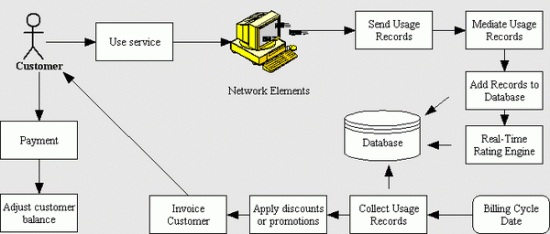

Figure 3.2: System Architecture

## 

## 3.6.3 Database Tables/Queries Structures

The database is used to store all information that pertain the course allocation and timetable generation records. Below are the database table for the new system.

**Table 1: Admin Details**

**Top of Form**

| **Name** | **Type** | **Extra** |
| --- | --- | --- |
| **id Primary** | int(11 | AUTO_INCREMENT |
| **Name** | varchar(50) |  |
| **Email** | varchar(50) |  |
| **Password** | varchar(50) |  |

**Table 2: Invoice Item Table**

Top of Form

| **Name** | **Type** | **Extra** |
| --- | --- | --- |
| id Primary | int(11) | AUTO_INCREMENT |
| order_id | int(11) |  |
| code | varchar(250) |  |
| name | varchar(250) |  |
| quantity | int(11) |  |
| price | int(11) |  |
| Total | int(11) |  |

Bottom of Form

**Table 3: Customers Details**

Top of Form

| **Name** | **Type** | **Extra** |
| --- | --- | --- |
| id Primary | int(11) | AUTO_INCREMENT |
| seaportno   Index | varchar(250) |  |
| surname | varchar(250) |  |
| firstname | varchar(250) |  |
| Midlle_name | varchar(250) |  |
| Phone number | Varchar(250) |  |
| Email | varchar(255) |  |
| seaport | varchar(250) |  |
| date | timestamp |  |

Bottom of Form

**Table 4: Invoice Table**

Top of Form

| **Name** | **Type** | **Extra** |
| --- | --- | --- |
| id Primary | int(11) | AUTO_INCREMENT |
| bill_idIndex | int(11) |  |
| User_id | int(11) |  |
| Billing_no | varchar(250) |  |
| Seaport_no | varchar(250) |  |
| Bill_date | Varchar(250) |  |
| Customer name | Varchar (250) |  |
| Phone number | varchar(255) |  |
| Email | varchar(255) |  |
| Receiver name | varchar(255) |  |
| date | timestamp |  |
| Total before tax | int(11) |  |
| Total after tax | int(11) |  |
|  |  |  |

Bottom of Form

## 3.6.4 Entity Relationship Modelling

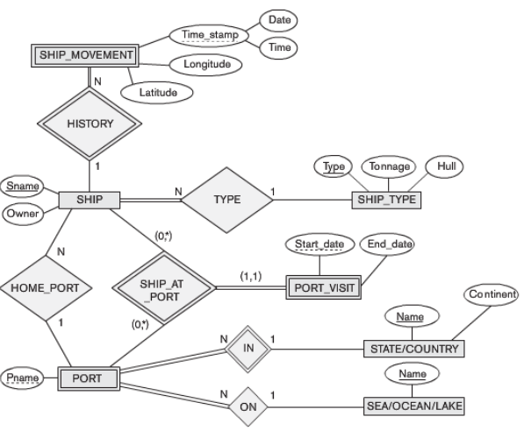

Figure 3.3: Entity Relationship Modelling

## 3.6.5 Input and Output Design

**ADD CUSTOMER**

Tracking Number

Surname

First Name

Other Name

Gender

Phone Number

Email address

Address

LGA

State

**SUBMIT**

Figure 3.4: Add Customer

**LOGIN**

**LOGIN**

**LOGIN**

Figure 3.5: Login form

**GENERATE BILL**

Item name

Quantity

Price

Total

Item name

Quantity

Price

Total

Sub Total

Tax

Total

**+ADD MORE**

**- DELETE**

**GENERATE BILL**

Figure 3.6: Generate Bill

**ADD LECTURER**

## 

## 3.7 System Requirements Specification

## 3.7.1 Hardware Requirements

The software to be design needs the following hardware for an effective operation of the newly designed system.

1. A system running on intel, P(R) duo core with higher processor
2. The-Random Access Memory (RAM) should be at least 512MB.
3. At least 20-GB hard disk.
4. A monitor.

## 3.7.2 Software Requirements

The software requirements include:

1. A window 7 or higher version of operating system.
2. XAMP or WAMP for Database
3. PHP
4. MySQL
5. Browser

## 3.7.3 Personnel Requirement

Any computer literate who has a technical knowhow of internet surfing can use the system because it is user friendly.

# CHAPTER FOUR

# RESULTS AND DISCUSSION

## 4.1 Introduction

The new system is designed using PHP and MySQL programming language for easy records inserting and updating. This system will help in managing and easily retrieving of information from the system for management purposes.

## 4.2 Results

**4.2.1 Login Interface**

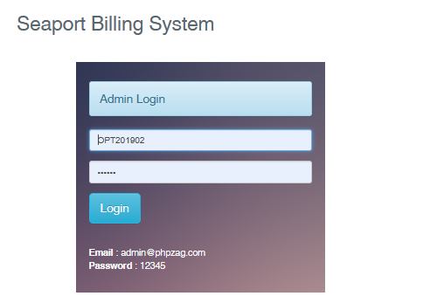

Figure 4.1: Login page interface

Figure 4.1 the login interface allows the Administrator to enter his username and password to get access to the system.

**4.2.2 Invoice List Interface**

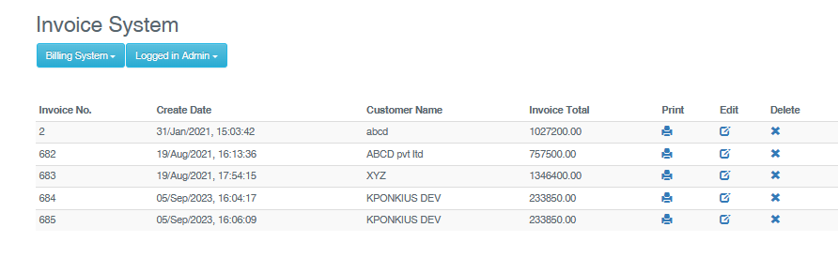

Figure 4.2: Invoice List Interface

Figure 4.2 above shows all the generated billing for customers that are in the system with their names and amount

**4.2.3 Create Bill Interface**

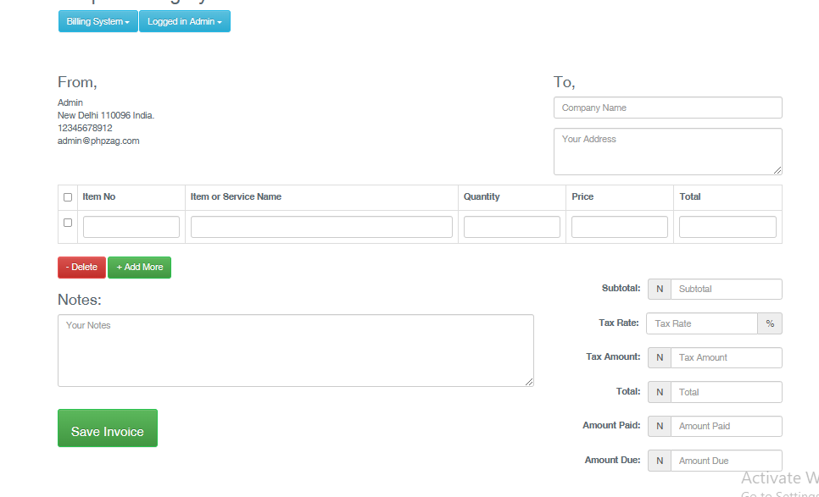

Figure 4.3: Create Bill Interface

Figure 4.3 is this section is used to create a bill for a particular customer or client showing the service or product name, amount rate and client’s name.

**4.2.4 Invoice interface**

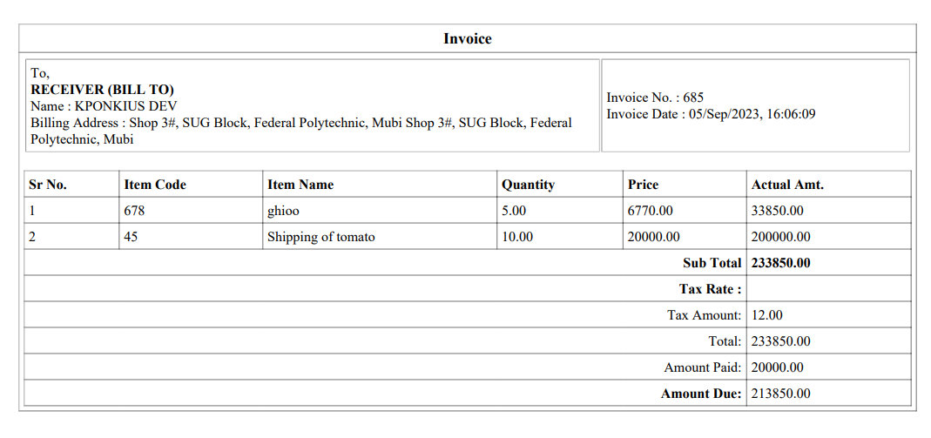

Figure 4.4: Invoice Interface

Figure 4.4 above shows the invoice or bill generated for a particular user with the service or product charge stating the amount and client’s address.

## 4.3 Discussion

4.2.1 Login Interface: The Login Interface is the gateway for authorized users to access the Seaport Billing System securely. It typically includes fields for entering usernames and passwords. Only authenticated personnel, such as seaport administrators and staff, can access the system to perform billing-related tasks.

4.2.2 Invoice List Interface: The Invoice List Interface displays a comprehensive list of invoices that have been generated within the Seaport Billing System. It typically includes details such as invoice numbers, dates, and billing amounts for various seaport services provided to clients. This interface allows administrators to track and manage invoices efficiently.

4.2.3 Create Bill Interface: The Create Bill Interface is a crucial component of the system, enabling seaport administrators to generate bills for seaport services provided to clients. It typically includes options to select the type of service, input relevant details, specify billing rates, and calculate the total amount due. This interface ensures accurate billing for seaport services.

4.2.4 Invoice Interface: The Invoice Interface provides a detailed view of a specific invoice. It typically includes a breakdown of charges for various seaport services, a summary of the total amount due, and payment options. Clients can access this interface to review and make payments for their invoices, while administrators can use it to assist clients with billing inquiries.

Collectively, these interfaces form the core components of the Computerized Based Seaport Billing System, designed to streamline billing processes, enhance financial transparency, and improve the management of invoices within seaport facilities.

## 4.4 User manual

The following are the necessary steps to take in order to use the system efficiently and effectively.

1. Load the url of the system <https://localhost/invoice/> the welcome page will be displayed.
2. Click on the **Proceed** button to proceed to the main system.
3. If you created an account, provide your login details by entering your username and password.
4. Depending on the login details provided you will be automatically directed to the dashboard.
5. The various task that you can perform on the portal will be displayed on the sidebar of the dashboard.

# CHAPTER FIVE

# SUMMARY, CONCLUSION AND RECOMMENDATIONS

## 5.1 Summary

In summary, the "Design and Implementation of a Computerized Based Seaport Billing System" marks a significant milestone in the field of seaport management and financial operations. This system has been meticulously developed to modernize and streamline the complex billing processes within seaport facilities, resulting in improved efficiency, accuracy, and financial transparency.

The system provides a comprehensive platform that empowers seaport administrators to seamlessly manage invoices, create bills, and maintain an organized record of financial transactions. The successful implementation of this system simplifies billing procedures, minimizes errors, and enhances overall operational efficiency within seaports.

## 5.2 Conclusion

The design and implementation of the Computerized Based Seaport Billing System have yielded concrete benefits for seaport facilities and their clients. This project showcases the transformative power of technology in simplifying billing procedures, improving financial transparency, and fostering smoother operations within seaports.

The successful implementation of this system sets a precedent for seaport management worldwide, offering a model for other seaports looking to modernize their billing and financial management processes.

## 5.3 Recommendations

Based on the successful implementation of the Computerized Based Seaport Billing System, several recommendations can be made for its continued improvement and broader adoption:

1. User Training: Provide comprehensive training to seaport administrators and staff to ensure efficient utilization of the system.
2. Integration with Accounting Software: Explore opportunities to integrate the billing system with accounting software for seamless financial record-keeping.
3. Client Portal: Develop a client portal to allow clients to access and manage their invoices and payments conveniently.

## 5.4 Contribution to Knowledge

This project contributes to knowledge in several key areas:

Seaport Management: It demonstrates how technology can significantly improve billing and financial management processes within seaport facilities.

Financial Transparency: The system underscores the importance of financial transparency in seaport operations and client satisfaction.

## 5.5 Area for Further Work

Future work in this area could include:

Advanced Reporting: Implement advanced reporting and analytics features to provide administrators with insights into billing trends and financial data.

Automated Payment Processing: Explore options for integrating automated payment processing solutions for client convenience.

Security Enhancements: Continuously monitor and enhance data security measures to safeguard financial information.

Integration with Port Operations: Extend the system's capabilities to integrate with other seaport operations and management systems for comprehensive facility management.

# REFERENCES

Adams, K. (2022). The Role of Automation in Educational Financial Management. *Journal of Information Technology in Education,* 15(3), 120-135.

Aguinis, K., & Kraiger, J. (2022). The Impact of Payment Systems on Error Reduction in Educational Institutions. *International Journal of Educational Finance,* 20(1), 56-70.

Allen, D. & James, M. (2021). Retaining Talent: The Relationship between Rewards, Engagement, and Turnover. *Journal of Management,* 46(8), 1300-1328.

Allen, D. G., Bryant, P. C., & Vardaman, J. M. (2021). Retaining Talent: The Relationship between Rewards, Engagement, and Turnover. *Journal of Management,* 46(8), 1300-1328.

Anderson, L., & Schalk, S. (2018). Ensuring Data Security in Payment Systems for Educational Institutions. *International Journal of Cybersecurity*, 18(1), 45-60.

Armstrong, M. (2019). *Armstrong's Handbook of Human Resource Management Practice*. Kogan Page Publishers.

Bendl, Y. (2021). Application of Predictive Modeling in Education: A Review. *Journal of Computers in Education,* 8(1), 19-37.

Cable, S. M., & Judge, A. (2016). Success Factors and Barriers of Adopting the Automated System of Student Affairs in Saudi Universities. *International Journal of Higher Education,* 8(3), 1-9.

Cai, X., Li, Y., Zhang, X., & Xu, Z. (2020). Factors Influencing Corporate Financial Transparency: Evidence from Chinese Listed Port Companies. Sustainability, 12(5), 1880. <https://doi.org/10.3390/su12051880>

Denisi, U. & Kluger, W. (2020). Mobile Property Management Systems: A Study of Design and Implementation. *Information Systems Frontiers*, 1-14.

Dennis, A., Wixom, B. H., & Tegarden, D. (2014). Systems Analysis and Design (6th ed.). John Wiley & Sons.

Dhillon, O. & Davenport, T. H. (2019). Putting the Enterprise into the Enterprise System. Harvard Business Review, 76(4), 121-131.

Elmasri, R., & Navathe, S. B. (2019). *Fundamentals of Database Systems.* Pearson, New York.

Ghazal, O., Ionita, H. & Gorges, O. (2020). An Artificial Intelligence Platform for Property Management: *A Conceptual Model. Computers in Industry*, 125, 103-379.

Goblar, N. (2022). Decision Support System in Higher Education: A Case Study of an Adaptive Learning Management System. *Journal of Computers in Education,* 8(2), 215-239.

Illmakunnas, H. (2023). Adoption of E-payment Systems in Higher Education: A Comparative Study*. International Journal of Educational Technology*, 14(3), 57-72.

Jagero, R., & Kangethe, A. (2020). The Importance of Financial Transparency in Educational Institutions. *Journal of Education Finance and Policy,* 25(2), 89-104.

Jurban, L., Turner, R., & Gonzalez, E. (2023). Improving Financial Management in Universities with Payment Systems. *Journal of Higher Education Management,* 16(2), 78-92.

Kalesh, S. & Tuwei, J. (2022). Web-based Rental Property Management System for Efficient and Effective Property Management. *Journal of Engineering Technology*, 18(1), 221-229.

Kapoor, A., & Singh, P. (2020). Digital Transformation in Compensation and Benefits Management. *International Journal of Recent Technology and Engineering*, 9(2), 6742-6746.

Lazear, S., & Rosen, M. (2023). Student Perspectives on Payment Systems in Higher Education. *International Journal of Educational Technology*, 15(1), 34-48.

Liu, K., Letchkov, N., Koychev, I., & Ivanov, B. (2020). Cloud-Based Property Management Systems. *In Proceedings of the International Conference on Advances in Business, Management and Law*, 7(1), 169-177.

Mahmud, N. (2020). Evaluation of Records Management Systems in Public Universities in Kenya. *International Journal of Information Systems and Project Management,* 8(3), 43-62.

Martins, A., Proença, T., & Gonçalves, R. (2020). Employee Compensation, Incentives, and Innovation. *Research in Human Resource Management (RHRM),* 12(1), 45-54.

Mathe, U., Lee, L., Ming, I., & Hashim, L. (2021). The Role of Management Information Systems in Data Analytics: A Strategic Perspective on Global Business Environments. *Information Systems Frontiers,* 22(4), 909-924.

Mell, P., & Grance, T. (2011). The NIST Definition of Cloud Computing. National Institute of Standards and Technology (NIST). <https://nvlpubs.nist.gov/nistpubs/Legacy/SP/nistspecialpublication800-145.pdf>

Motahari-Nezhad, H. R., Stephenson, B., Shahbazian, M., & Foster, H. (2021). Database Management Systems. *In Handbook on Securing Cyber-Physical Critical Infrastructure* (pp. 195-217). Springer.

O'Brien, J. A., & Marakas, G. M. (2018). Management Information Systems (11th ed.). McGraw-Hill Education.

Olivera, M. & Martins, L. (2021). The Adoption of Property Management Systems in the Real Estate Sector. *Journal of Business and Management*, 23(2), 71-92.

Poon, J. M. (2019). The Impact of Non-Financial Rewards on Employee Engagement and Retention. *Employee Relations*, 41(2), 333-348.

Rahman, L., Huang, O., Tim, R. & Gehrke, J. (2020). *Database Management Systems*. McGraw-Hill.

Ramakrishnan, M. & Gehrke, M. (2020). An Integrated Framework for E-Records Management System (ERMS) Development: A Study on Bangladesh Government Sector. *International Journal of Electronic Government Research*, 16(3), 19-38.

Reddy, B. S., & Kumar, G. P. (2021). Personalized Compensation and Benefits: A New Paradigm. *International Journal of Applied Engineering Research*, 16(1), 69-73.

Rizvi, S., Khan, M. A., Bhatti, R. A., & Ziauddin, Z. (2021). A Comparative Study of Database Management Systems. *Journal of Information Systems and Technology Management*, 18, 202-1134.

Shore, F. (2019). A Model for Developing a Student Management System (SMS) in Saudi Universities. *Journal of Educational Computing Research,* 58(3), 523-552.

Singhal, J. (2021). Digital Transformation in Higher Education: Advancements and Challenges. *International Journal of Educational Technology,* 12(4), 65-79.

Sustainable Growth: Economic growth that meets the needs of the present without compromising the ability of future generations to meet their own needs.

Tayebi, A., & Albadvi, A. (2023). Data Warehouse and Its Applications in Business. Procedia Technology, 9, 1230-1238. <https://doi.org/10.1016/j.protcy.2013.12.135>

Tziner, J. & Vardi, K. (2018). Cloud-Based Property Management System with Mobile Integration for Small and Medium-Sized Landlords. *Journal of Systems and Information Technology*, 23(3), 486-503.

UNCTAD. (2021). Review of Maritime Transport 2021. United Nations Conference on Trade and Development. https://unctad.org/system/files/official-document/rmt2021_en.pdf

United Nations. (2015). Transforming Our World: The 2030 Agenda for Sustainable Development. United Nations. <https://sustainabledevelopment.un.org/post2015/transformingourworld>

Vroom Q. (2017). A Framework for Smart Rental Property Management. *IEEE Access*, 8, 134127-134139.

Wasana, A. (2020). Design and Development of Mobile Applications for Property Management. *International Journal of Information Systems and Project Management,* 9(2), 5-19.

Wayne, K. (2022). Digitalizing Student Fee Management: Challenges and Opportunities. *Journal of Educational Administration,* 46(1), 89-105.

Welch, M., & Jackson, S. E. (2017). Rethinking Diversity in Research on Organizations: Toward a Structural Perspective. *Research in Organizational Behavior*, 27, 3-30.

World Economic Forum. (2018). Future of Jobs Report 2018. World Economic Forum. <https://www.weforum.org/reports/the-future-of-jobs-report-2018>

Wu, L., & Zhu, C. (2021). Security Considerations in Designing University Payment Systems. *Journal of Information Security,* 35(2), 213-228.

Zhang, W., Li, S., & Yang, Y. (2019). Research on the Real-Time Data Integration of Ports Based on the "Internet +". International Conference on Education, Management, Computer and Society (EMCS). <https://doi.org/10.2991/emcs-19.2019.60>